**Business Case: Target SQL**

Data from 100,000 orders placed at Target in Brazil between 2016 and 2018 is included in this business case. It is the top retail chain in America.   
Eight tables include data about orders from several aspects, including order status, payment information, order location and time, client who made the purchase, items in the order, product details, vendor information, order reviews, etc.

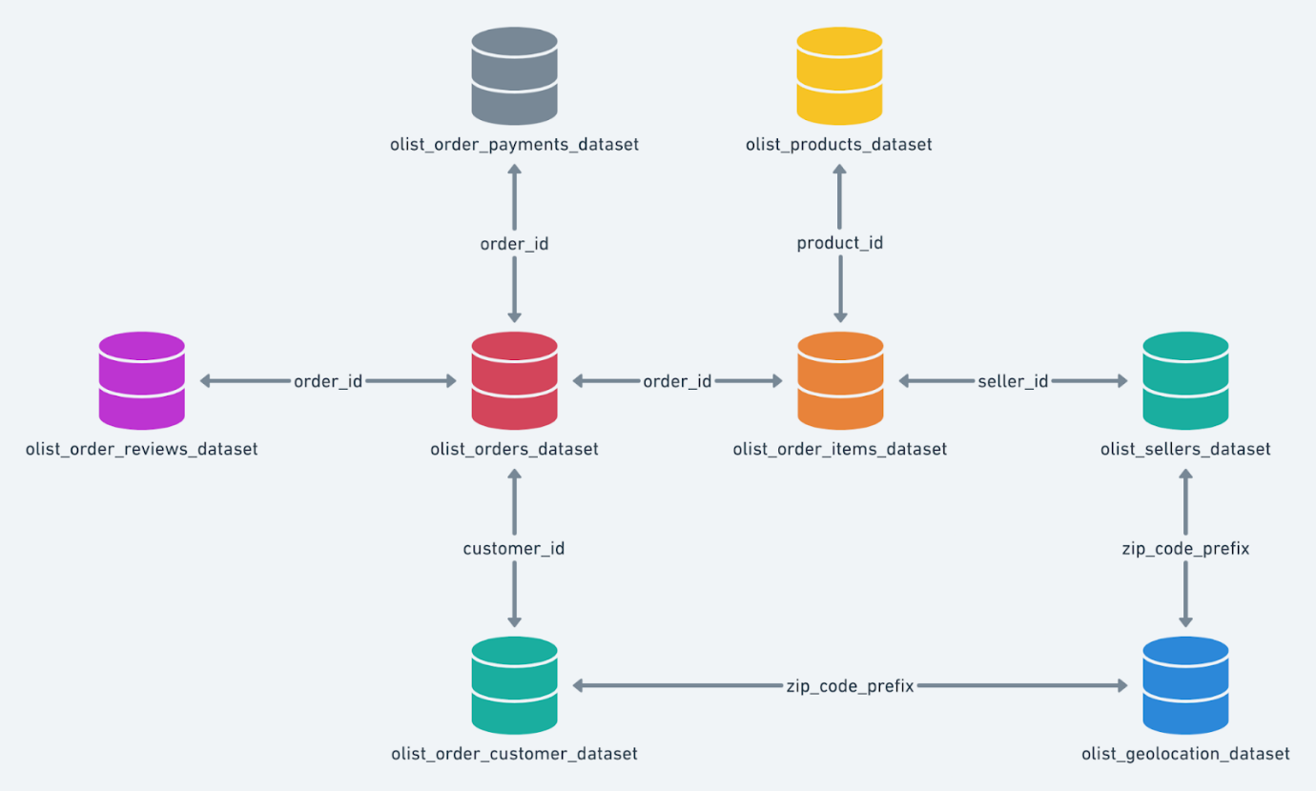

**ANAYLISIS**

1. **Initial exploration of dataset**
   * 1. Data type of all columns of different tables in the "Target" dataset.

**🡪 🡪** *Query:*

SELECT

  table_schema,

  table_name,

  column_name,

  data_type

FROM

  `Target`.INFORMATION_SCHEMA.COLUMNS;

**🡪 🡪** *Result*:

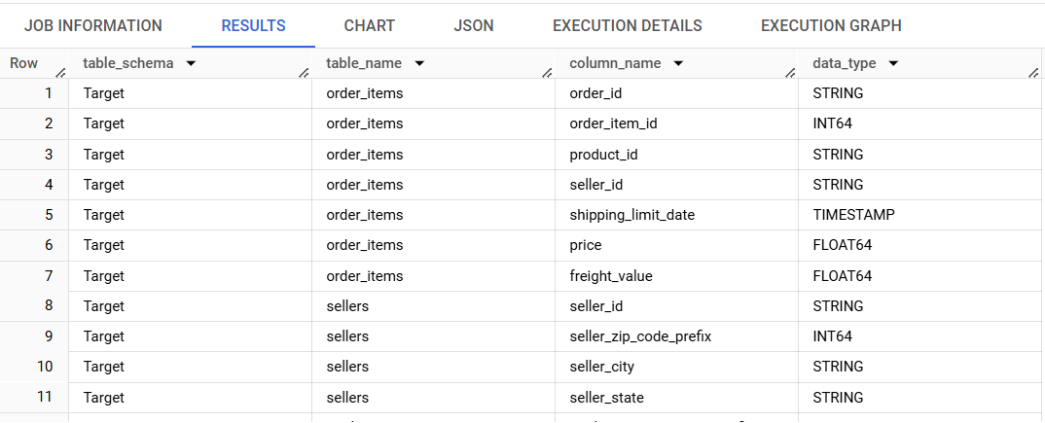

* + 1. The timespan of available data.

**🡪 🡪** *Query:*

SELECT

  MIN(DATE(order_purchase_timestamp)) AS first_order_date,

  MAX(DATE(order_purchase_timestamp)) AS last_order_date

FROM

  `Target.orders`;

**🡪 🡪** *Result*:

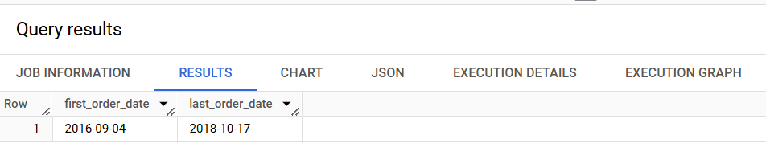

* + 1. Number of cities per State of customers who ordered during the given period.

**🡪 🡪** *Query:*

SELECT

  DISTINCT c.customer_state , count (c.customer_city) as No_of_Cities

FROM

  `Target.customers` c

RIGHT JOIN

  `Target.orders` o

ON

  c.customer_id = o.customer_id

GROUP BY c.customer_state

ORDER BY No_of_Cities DESC, c.customer_state;

**🡪 🡪** *Result*:

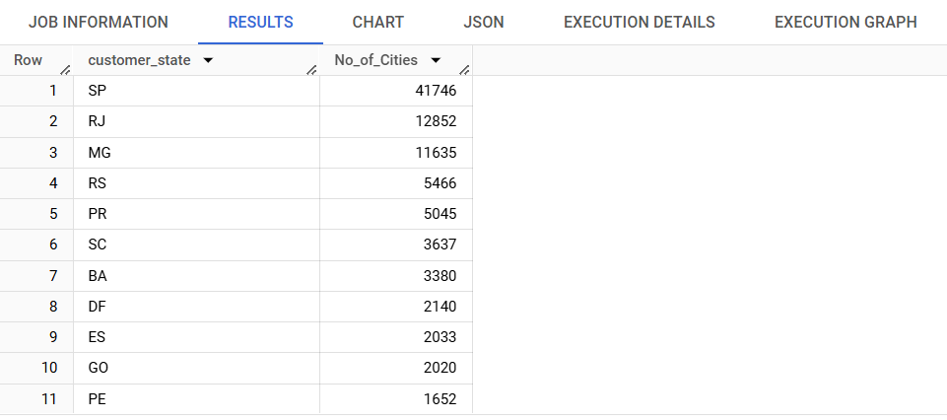

* + 1. Distribution of total orders as per their status.

**🡪 🡪** *Query:*

SELECT

  DISTINCT c.customer_state , count (c.customer_city) as No_of_Cities

FROM

  `Target.customers` c

RIGHT JOIN

  `Target.orders` o

ON

  c.customer_id = o.customer_id

GROUP BY c.customer_state

ORDER BY No_of_Cities DESC, c.customer_state;

**🡪 🡪** *Result*:

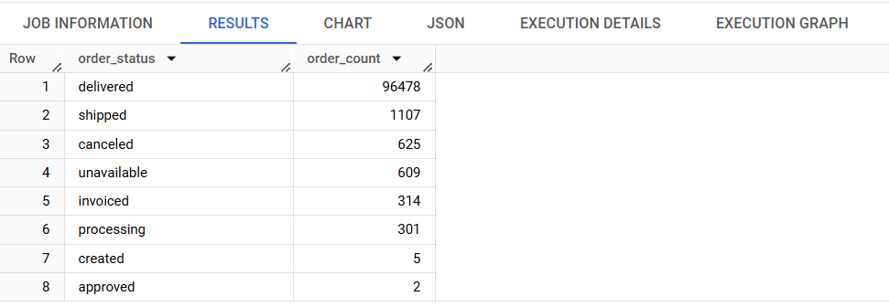

1. **In-Depth Analysis**
   * 1. Top 10 cities with largest customer base.

**🡪 🡪** *Query:*

SELECT

time_period, order_count,

ROUND((((order_count - LAG(order_count) OVER(ORDER BY year, month)) / LAG(order_count) OVER(ORDER BY year, month))* 100), 2) AS growth_percent

FROM

(SELECT

EXTRACT (MONTH FROM order_purchase_timestamp) AS month,

EXTRACT (YEAR FROM order_purchase_timestamp) AS year,

FORMAT_DATE('%b %Y', DATE(order_purchase_timestamp)) AS time_period,COUNT(order_id) AS order_count

FROM `Target.orders`

WHERE order_status = 'delivered'

GROUP BY month, year, time_period) as T1

ORDER BY year, month;

**🡪 🡪** *Result*:

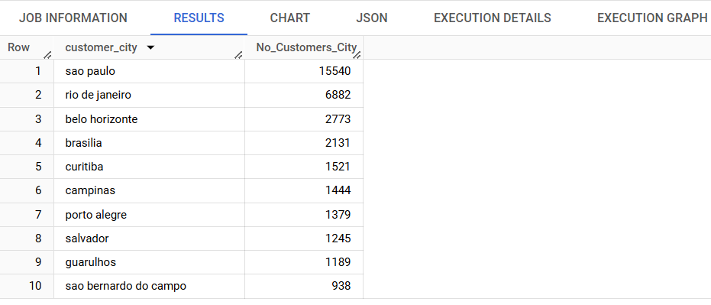

* + 1. Top 10 cities with the greatest number of orders.

**🡪 🡪** *Query:*

SELECT

  Tempo.geolocation_city, COUNT(Tempo.geolocation_city) as Orders_per_City

FROM

  `Target.orders` as o

INNER JOIN

  (SELECT c.customer_id ,g.geolocation_city

  FROM

    `Target.customers` as c

  INNER JOIN

    `Target.geolocation` as g

  ON

    c.customer_zip_code_prefix = g.geolocation_zip_code_prefix) AS Tempo

ON

  Tempo.customer_id = o.customer_id

GROUP BY

  Tempo.geolocation_city

ORDER BY

  Orders_per_City DESC

LIMIT 10

**🡪 🡪** *Result*:

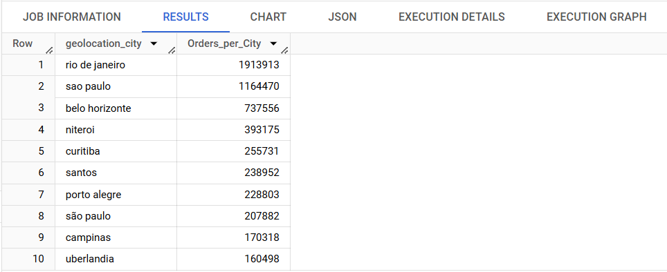

* + 1. Is there a growing trend in the no. of orders placed over the past years?

**🡪 🡪** *Query:*

SELECT

time_period, order_count,

ROUND((((order_count - LAG(order_count) OVER(ORDER BY year, month)) / LAG(order_count) OVER(ORDER BY year, month))* 100), 2) AS growth_percent

FROM

(SELECT

EXTRACT (MONTH FROM order_purchase_timestamp) AS month,

EXTRACT (YEAR FROM order_purchase_timestamp) AS year,

FORMAT_DATE('%b %Y', DATE(order_purchase_timestamp)) AS time_period,COUNT(order_id) AS order_count

FROM `Target.orders`

WHERE order_status = 'delivered'

GROUP BY month, year, time_period) as T1

ORDER BY year, month;

**🡪 🡪** *Result*:

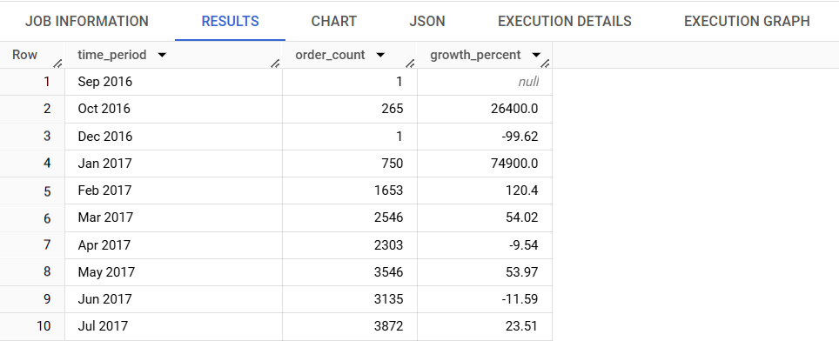

There is no concrete evidence to show any pattern that shows seasonality in orders placed. However, it is seen that there is growing trend in no. of orders placed over the past years.

* + 1. What time do Brazilian customers tend to buy (Dawn, Morning, Afternoon or Night)?

**🡪 🡪** *Query:*

SELECT order_time, count(*) AS Total_Orders

FROM

(SELECT

    order_id,

    CASE

      WHEN TIME(order_purchase_timestamp) BETWEEN "00:00:00" AND "07:00:00" THEN "Dawn"

      WHEN TIME(order_purchase_timestamp) BETWEEN "07:00:01" AND "12:00:00" THEN "Morning"

      WHEN TIME(order_purchase_timestamp) BETWEEN "12:00:01" AND "18:00:00" THEN "Afternoon"

      WHEN TIME(order_purchase_timestamp) BETWEEN "18:00:01" AND "23:59:59" THEN "Night"

    END AS order_time

  FROM

    `Target.orders`) AS ORDER_SLOTS

GROUP BY order_time

ORDER BY Total_Orders DESC

**🡪 🡪** *Result*:

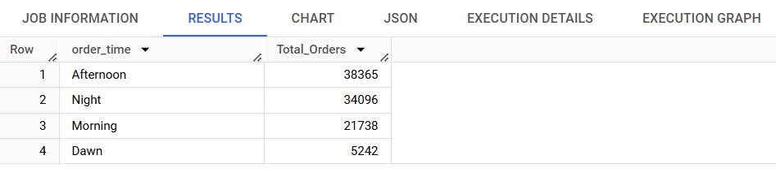

It is seen that the Brazilian customers tend to place most of their orders during afternoon and night.

1. **Evolution of E-commerce orders in the Brazil region**
   * 1. Month on month orders by states

**🡪 🡪** *Query:*

SELECT

  state ,year, month, time_period , total_orders,

  LAG(total_orders) OVER(PARTITION BY state ORDER BY year, month ) AS prev_month_orders_count,

  ROUND(((total_orders - LAG(total_orders) OVER(PARTITION BY state ORDER BY year, month )) / LAG(total_orders) OVER(PARTITION BY state ORDER BY year, month))* 100,2) AS MoM_percent_growth

FROM (

  SELECT

    state, time_period, year,month,

    COUNT(*) AS total_orders

  FROM (

    SELECT

      o.order_id, o.order_purchase_timestamp,

      EXTRACT(YEAR FROM order_purchase_timestamp) AS year,

      EXTRACT(Month FROM order_purchase_timestamp) AS month,

      FORMAT_DATE('%b %Y', DATE(order_purchase_timestamp)) AS time_period,

      c.customer_state AS state

    FROM

      `Target.orders` o

    JOIN

      `Target.customers` c

    USING

      (customer_id)

    ORDER BY

       year, month) Tempo

  GROUP BY

    state, time_period,year, month) Tempo1

  ORDER BY state, year, month;

**🡪 🡪** *Result*:

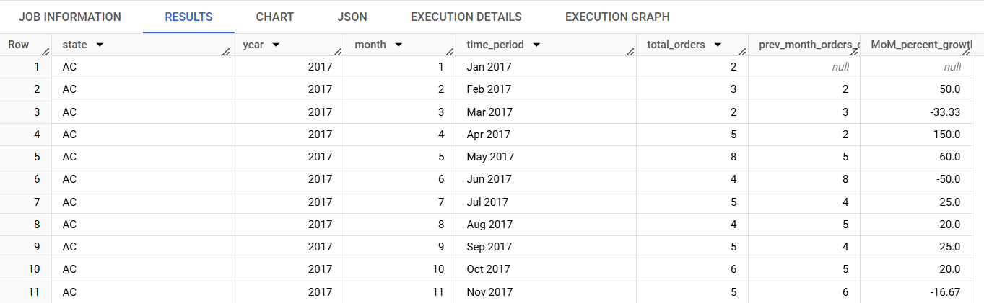

* + 1. Distribution of customers across states in Brazil

**🡪 🡪** *Query:*

SELECT

  customer_state AS State,

  COUNT(*) AS Total_Customers

FROM

  `Target.customers`

GROUP BY

  customer_state

ORDER BY

  total_customers DESC;

**🡪 🡪** *Result*:

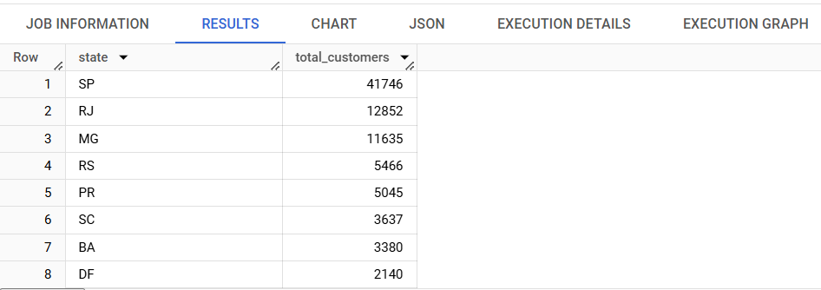

1. **Impact on Economy: Analyzing the money movement by e-commerce by looking at order prices, freight and others.**
2. Percentage increase in the cost of orders from year 2017 to 2018 (including months between Jan to Aug only).

**🡪 🡪** *Query:*

SELECT

  *,

COALESCE((ROUND(((Total_Order_Value - LAG(Total_Order_Value) OVER(ORDER BY year))/LAG(Total_Order_Value) OVER(ORDER BY year))* 100, 2)), 0) AS YoY

FROM (

  SELECT

    year,

    ROUND(SUM(payment_value), 2) AS Total_Order_Value

  FROM (

    SELECT

      o.order_id,

      o.order_purchase_timestamp,

      EXTRACT(MONTH FROM o.order_purchase_timestamp) AS month,

      EXTRACT(YEAR FROM  o.order_purchase_timestamp) AS year,

      p.payment_value

    FROM

      `Target.orders` o

    INNER JOIN

      `Target.payments` p

    USING

      (order_id)

    WHERE

      o.order_status = "delivered") AS T

  WHERE

    month BETWEEN 1 AND 8

  GROUP BY year) AS T1

ORDER BY Year;

**🡪 🡪** *Result*:

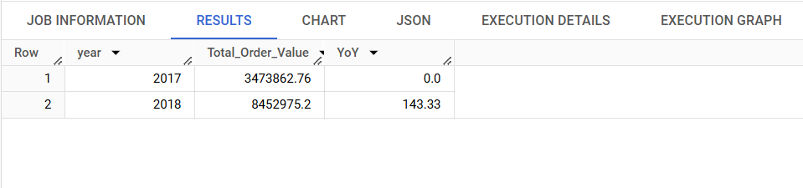

1. Total & Average value of order price and freight value for each state.

**🡪 🡪** *Query:*

SELECT

  c.customer_state,

  ROUND(SUM(oi.price)) AS Total_Price,

  ROUND(AVG(oi.price)) AS Avg_Price,

  ROUND(SUM(oi.freight_value)) AS Total_Freight,

  ROUND(AVG(oi.freight_value)) AS Avg_Freight

FROM

  `Target.order_items` AS oi

INNER JOIN

  `Target.orders` o

ON

  oi.order_id = o.order_id

INNER JOIN

  `Target.customers` c

ON

  c.customer_id = o.customer_id

GROUP BY

  c.customer_state;

**🡪 🡪** *Result*:

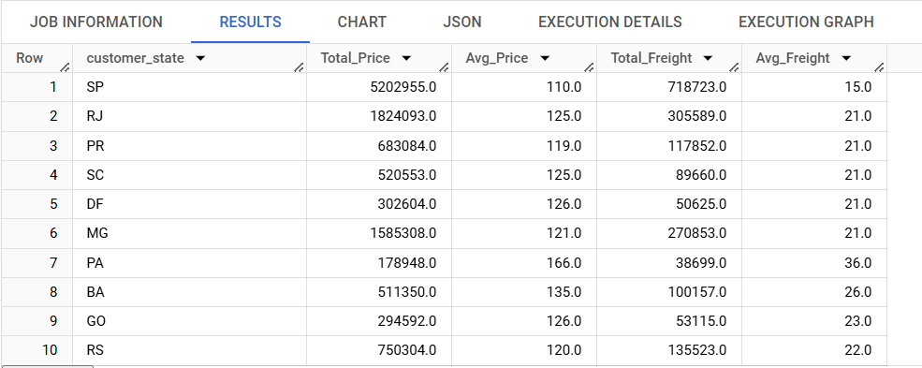

1. **Analysis based on sales, freight and delivery time.**
2. Number of days taken to deliver each order from the order’s purchase date as delivery time. Along with, the difference (in days) between the estimated & actual delivery date of an order.

**🡪 🡪** *Query:*

SELECT

    * ,T.Actual_Delivery_Time_in_Days - T.Estimated_Delivery_Time_in_Days AS Diff_Estimated_Delivery

FROM

(SELECT

  order_id,

  TIMESTAMP_DIFF(order_delivered_customer_date, order_purchase_timestamp, day) AS Actual_Delivery_Time_in_Days ,

  TIMESTAMP_DIFF(order_estimated_delivery_date, order_purchase_timestamp, day) AS Estimated_Delivery_Time_in_Days,

FROM

  `Target.orders`

WHERE

  order_status = "delivered") AS T;

**🡪 🡪** *Result*:

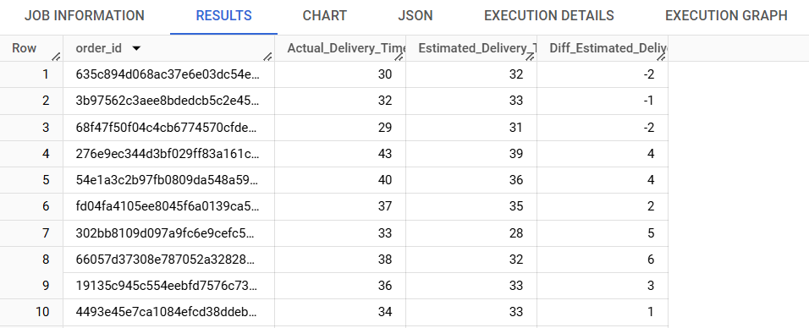

1. Ranking states with the highest & lowest average freight value.

**🡪 🡪** *Query:*

SELECT

  State,Avg_Freight_Value,

  ROW_NUMBER() OVER (ORDER BY Avg_Freight_Value) AS Ranking_for_Lowest,

  ROW_NUMBER() OVER (ORDER BY Avg_Freight_Value DESC) AS Ranking_for_Highest

FROM

  (SELECT DISTINCT c.customer_state as State,

    AVG(oi.freight_value) OVER (PARTITION BY c.customer_state) AS Avg_Freight_Value

  FROM

    `Target.order_items` AS oi

  INNER JOIN

    `Target.orders` AS o

  USING

    (order_id)

  INNER JOIN

    `Target.customers` AS c

  ON

    o.customer_id = c.customer_id) AS T

GROUP BY

  State, Avg_Freight_Value;

**🡪 🡪** *Result*:

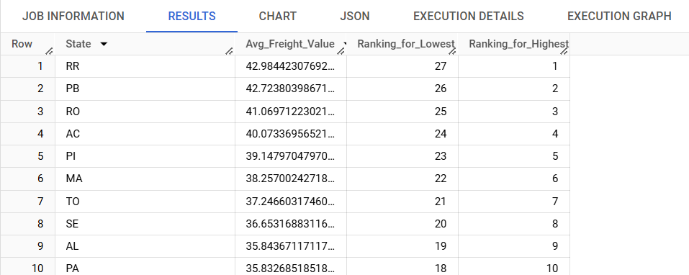

1. Top 5 states with the lowest average delivery time.

**🡪 🡪** *Query:*

SELECT

  DISTINCT c.customer_state ,AVG (o.Actual_Delivery_Time_in_Days) OVER (PARTITION BY c.customer_state) AS Avg_Delivery_Time

FROM

(SELECT

  customer_id, order_id,

  TIMESTAMP_DIFF(order_delivered_customer_date, order_purchase_timestamp, day) AS Actual_Delivery_Time_in_Days ,

  TIMESTAMP_DIFF(order_estimated_delivery_date, order_purchase_timestamp, day) AS Estimated_Delivery_Time_in_Days,

FROM

  `Target.orders`

WHERE

  order_status = "delivered") AS o

INNER JOIN

  `Target.customers` AS c

USING

  (customer_id)

ORDER BY Avg_Delivery_Time

LIMIT 5;

**🡪 🡪** *Result*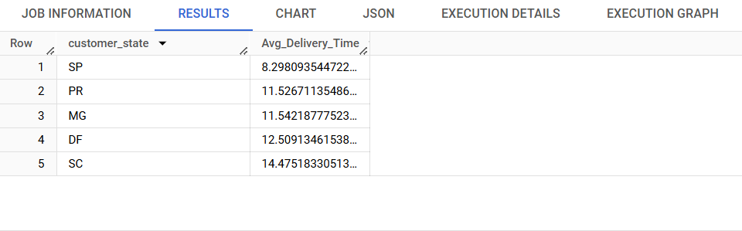The above data provides top 5 states with lowest average delivery time in days. The data for top 5 states with highest average delivery time can be retrieved by ordering the same data by “Avg_Delivery_Time” in descending order.

1. **Analysis based on the payments**
2. Month on month number of orders placed using different payment types.

**🡪 🡪** *Query:*

SELECT

  time_period,

  payment_type,

  COUNT(*) AS Total_Orders

FROM

  (SELECT

    p.order_id,

    p.payment_type,

    EXTRACT(YEAR FROM order_purchase_timestamp) AS Year,

    EXTRACT(Month FROM order_purchase_timestamp) AS Month,

    FORMAT_DATE('%b %Y', DATE(order_purchase_timestamp)) AS Time_Period

  FROM

    `Target.payments` AS p

  JOIN

    `Target.orders` AS o

  USING

    (order_id)) T

GROUP BY

  time_period, payment_type, T.YEAR, T.month

ORDER BY

  T.YEAR, T.month,payment_type;

**🡪 🡪** *Result*:

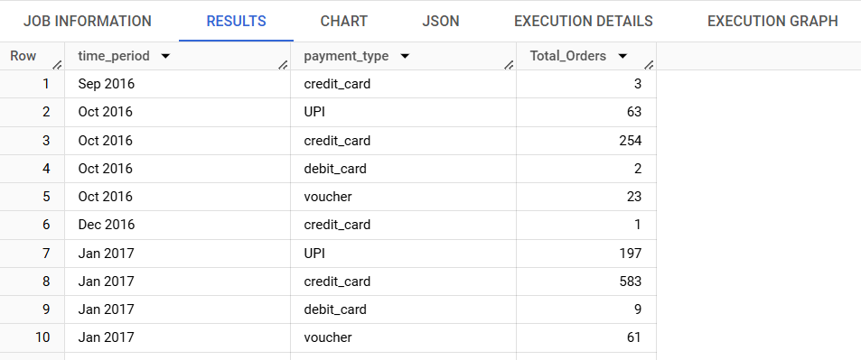

1. Count of orders based on the no. of payment instalments.

**🡪 🡪** *Query:*

SELECT

  payment_installments,

  COUNT(*) AS Total_Orders

FROM

  `Target.payments`

GROUP BY

  payment_installments;

**🡪 🡪** *Result*:

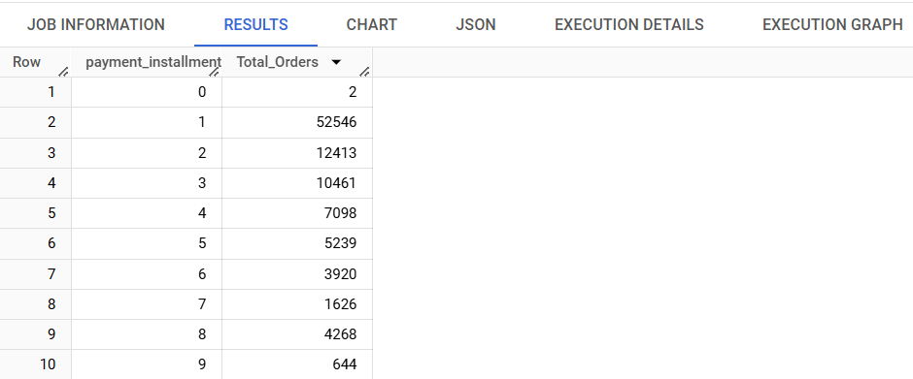

1. **Actionable Insights & Recommendations**
2. The orders trajectory shows a sharp rise in the volume of orders within a short period of time. Business in Brazil is growing quickly, according to the general trend, thus companies need to be prepared with more staff. Company may think about employing contract workers to reduce excessive risk.

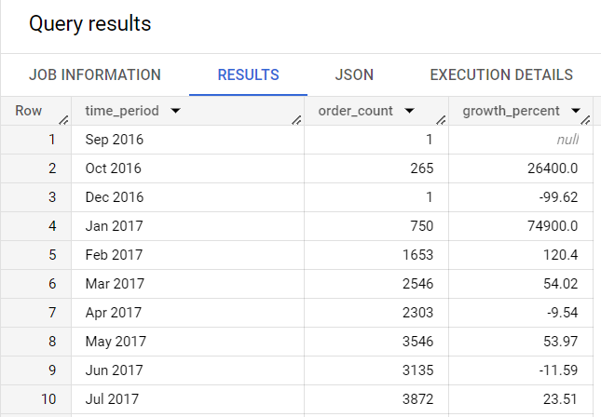

1. Total 609 orders were unavailable and 625 orders were cancelled during the given time period, which makes it to be around 1.2 % of total orders. We can reduce this number by studying the reasons behind order cancellation and items unavailability.

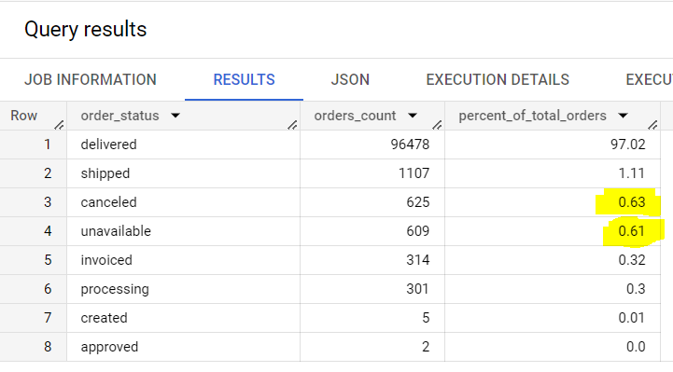

1. The query below calculates the ratio of review score for each is state. While, the extracted data is ordered to get the states with higher proportion of unsatisfied customers.

**🡪 🡪** *Query:*

SELECT

  customer_state AS State,

  ROUND(_1/Total_Reviews*100,1) AS R1,

  ROUND(_2/Total_Reviews*100,1) AS R2,

  ROUND(_3/Total_Reviews*100,1) AS R3,

  ROUND(_4/Total_Reviews*100,1) AS R4,

  ROUND(_5/Total_Reviews*100,1) AS R5

FROM

(SELECT *,(_1 + _2 + _3 + _4 +_5) AS Total_Reviews

FROM

(SELECT

  *

FROM (

  SELECT

    c.customer_state,

    orr.review_score

  FROM

    `Target.order_reviews` orr

  JOIN

    `Target.orders` o

  USING

    (order_id)

  JOIN

    `Target.customers` c

  USING

    (customer_id))

  PIVOT(COUNT(*) FOR review_score IN (1, 2, 3, 4, 5))) AS T)

  ORDER BY R1 DESC,R5;

**🡪 🡪** *Result*:

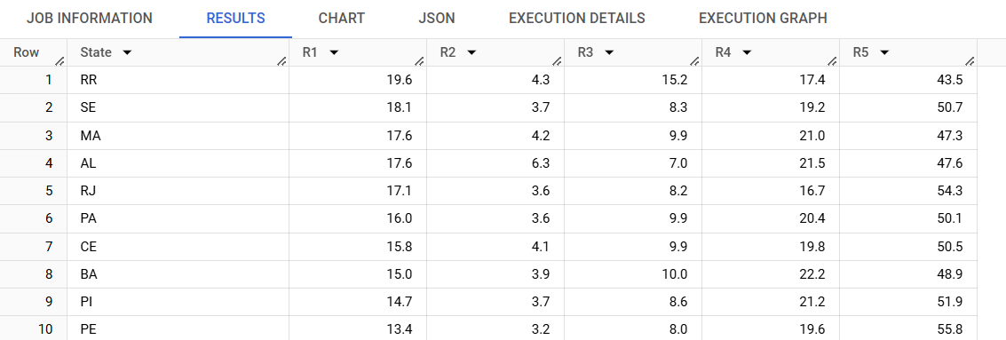

1. A closer look reveals that the majority of these complaints mention problems with deliveries that were delayed or that the consumer did not get. However, a lot of the negative reviews are also brought on by things that were shipped incorrectly or damaged. Therefore, the business should concentrate on improving its logistics in order to win over customers and increase profitability. The most popular review titles are displayed with the following query.

**🡪 🡪** *Query:*

SELECT

  review_comment_title, count(review_comment_title) as CNT

FROM

  `Target.order_reviews`

WHERE

  review_score IN (1,2)

GROUP BY

  review_comment_title

ORDER BY

  CNT DESC;

**🡪 🡪** *Result*:

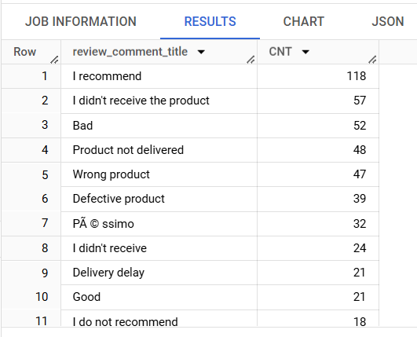

1. Rio de Janeirio, Sao Paulo and Belo Horizonte among others cities in Brazil that contribute the major chunk of orders. The company can upscale their businesses by improving their product offerings and logistics in order to attain higher customer satisfaction to gain more trust in these markets. The results of this analysis can be referred from “In-depth Analysis”, consisting the data for number of customers and number of orders placed per city.
2. Additionally, Brazilian customers show a tendency for shopping online during afternoon and night. The company can focus on scheduling and optimizing their digital marketing campaigns during these hours of the day to increasing customer engagement.